For more information call the Monroe County Health Department (270) 487-6782
www.monroecohealth.com
A1C provided by MCMC
Blood Pressure and Cholesterol provided by WKU Mobile Health
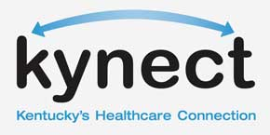
Kynectors will be onsite to assist with health insurance enrollment!

Free Screenings:
A 1C
B lood Pressure
C holesterol

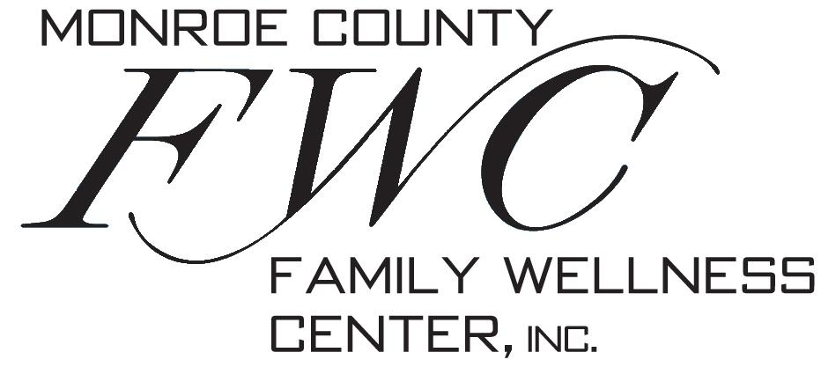
B=
Blood Pressure
<130/80
C=
Cholesterol
LDL < 100
A=
A1C <7%
For those with and at risk for Diabetes

Tuesday, November 18, 2014
9:00 a.m.-1:00 p.m.
Monroe Co. Family Wellness Center

