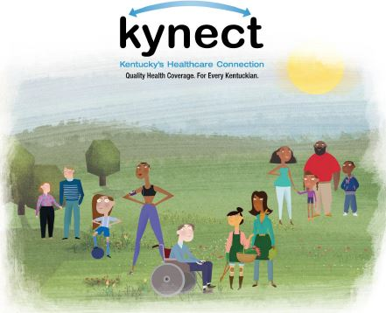
Need Insurance? Confused about Kynect?
You may be eligible RIGHT NOW for health insurance!
Stop by the Monroe County Health Department Monday April 13, 2015 from 9:00 AM until 3:00 PM and visit with a kynector.
For more details contact Monroe County Health Department 270 487-6782 or

Kynector Sandra Lindsey 270-202-7367
E-Mail: slindsey@casoky.org

